Let’s Celebrate  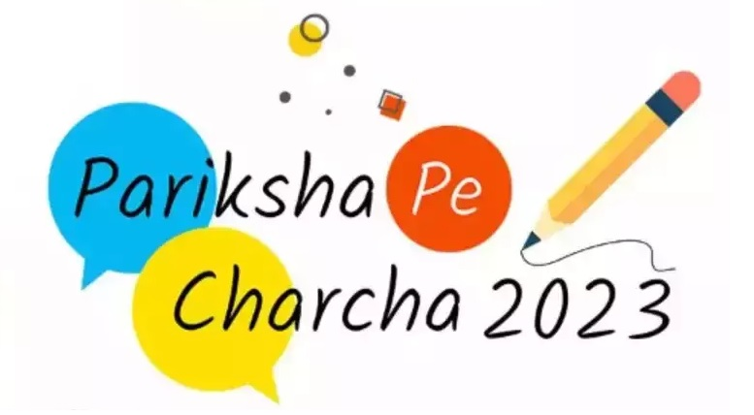  ON-THE-SPOT PAINTING COMPETITION  DATE & TIME  23rd January 2023  10:00 a.m. to 12:00 noon  THEME  Themes are based on the “MANTRAS” given in the book Exam Warriors written by Hon’ble Prime Minister of India  CERTIFICATE & AWARDS  Digital Certificates and “Exam Warrior” book will be provided to all the 100 participants.  Physical Certificates and a book will be given to top 5 winners. |  | Under the guidance of Ministry of Education, KVS HQ and KVS RO Jammu, our School is going to organize an on-the-spot painting competition for students of class IX to XII.

 |  | Title or Heading Here  In the same way you change the colors, you can update the fonts of the entire document easily! From the Design tab, choose a font combination that fits your taste.  Reset the theme to restore the template to its original state!  Customize Heading/Text  To change any of the text in this document, just click on the block of text you want to update! The formatting has already been programmed for ease of formatting. |  | “Large quote goes here.”
Title or Heading Here  You can easily change the overall colors of the template with just a few clicks. Go to the Design tab and click on Colors. From the list of colors, you can choose a different color scheme. As you hover over the different choices, you can see what the overall feel of the document will change with each different option.  Changed the color and want to go back to the original design? Easy! Just go back to the Design tab and choose the Themes option. From the list, click the option to reset the theme of this template. And just like that, your document color scheme will be restored to its original! |  |  |  | Title or Heading Here  In this panel, you can highlight even more information about your organization! Tell the audience why you are the best! Don’t be shy! Share, explain, and tell us what makes your company so great!  Plenty of text will fit in any of these panels. Simply click on the placeholders and add your own text.  Title or Heading Here  We think the design of this brochure is great as is! But, if you do not agree, you are able to make it yours by making a few minor design tweaks! Tips on updating specific features are available throughout this example text.

